**Attendance Application**

Documentation

**Specifications**

* Attendance
* Captures exact date and time
* Save the attendance data in excel file format
* Admin panel control
* Admin panel passkey
* Admin can changed passkey
* Can reset the passkey if needed

**Defaults**

* Default key – 012345
* Default reset key – PNB123456

**How to install?**

* Click the **installer**
* Then click **next**

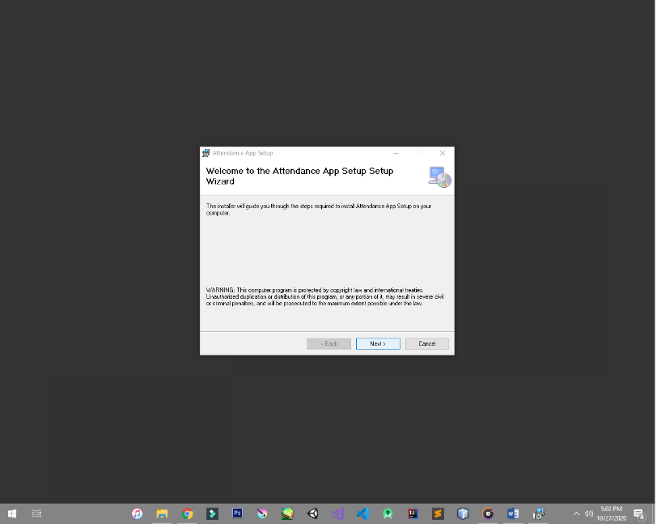

* Then click **everyone** as a recommended settings

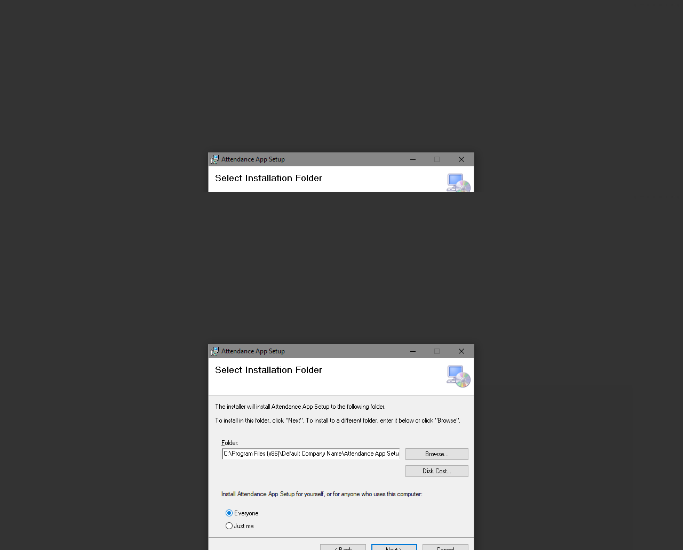

* Then pick the path for installation
* If you doesn’t sure about file directory/path please leave as is
* The recommended installation path is the default directory
* Then *copy the application directory* we will use it later on for *creating a shortcut*

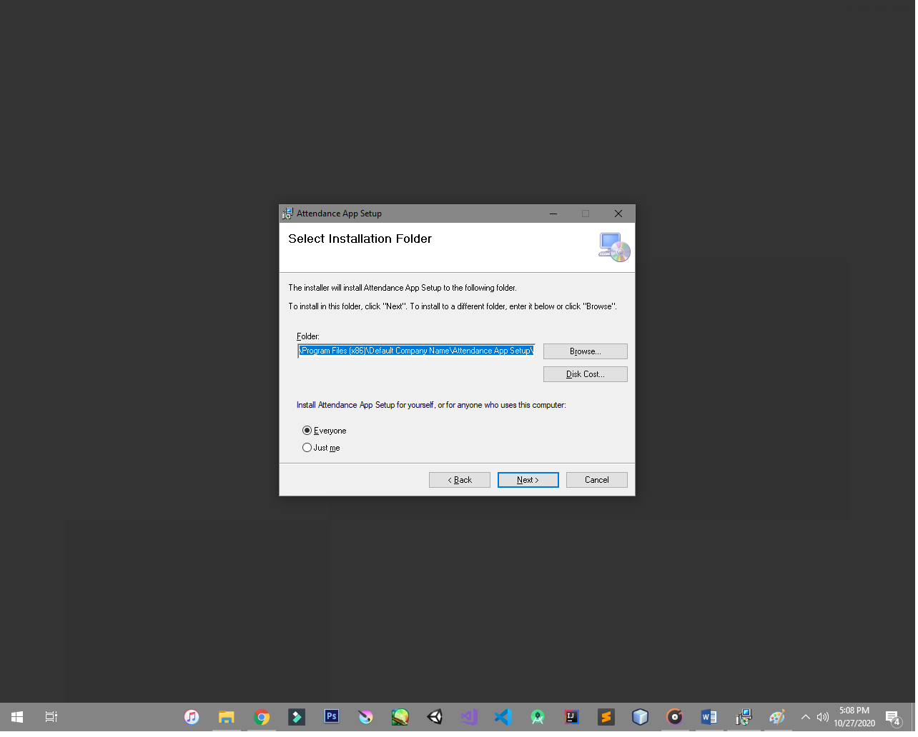

* Click **next**

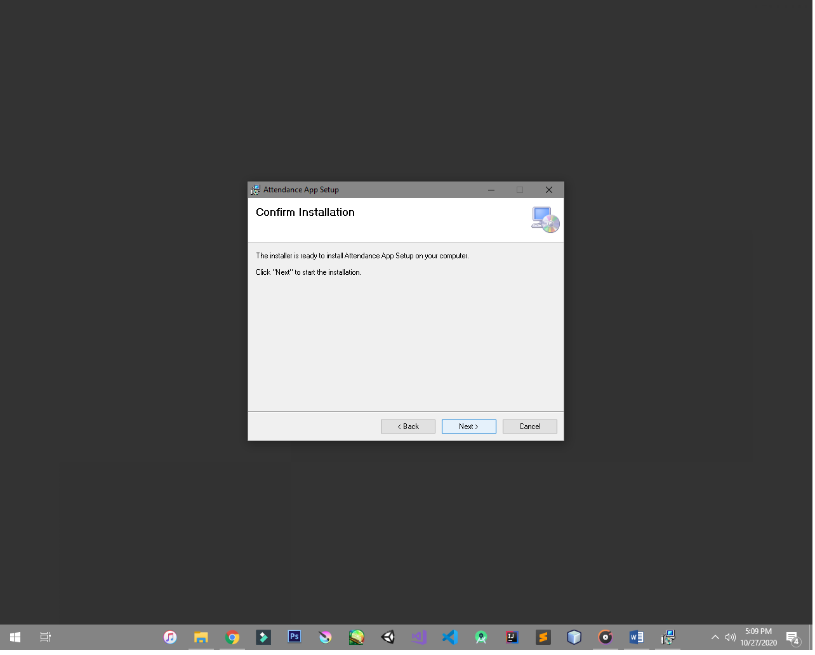

* Then close the installation tab after *installing successfully*

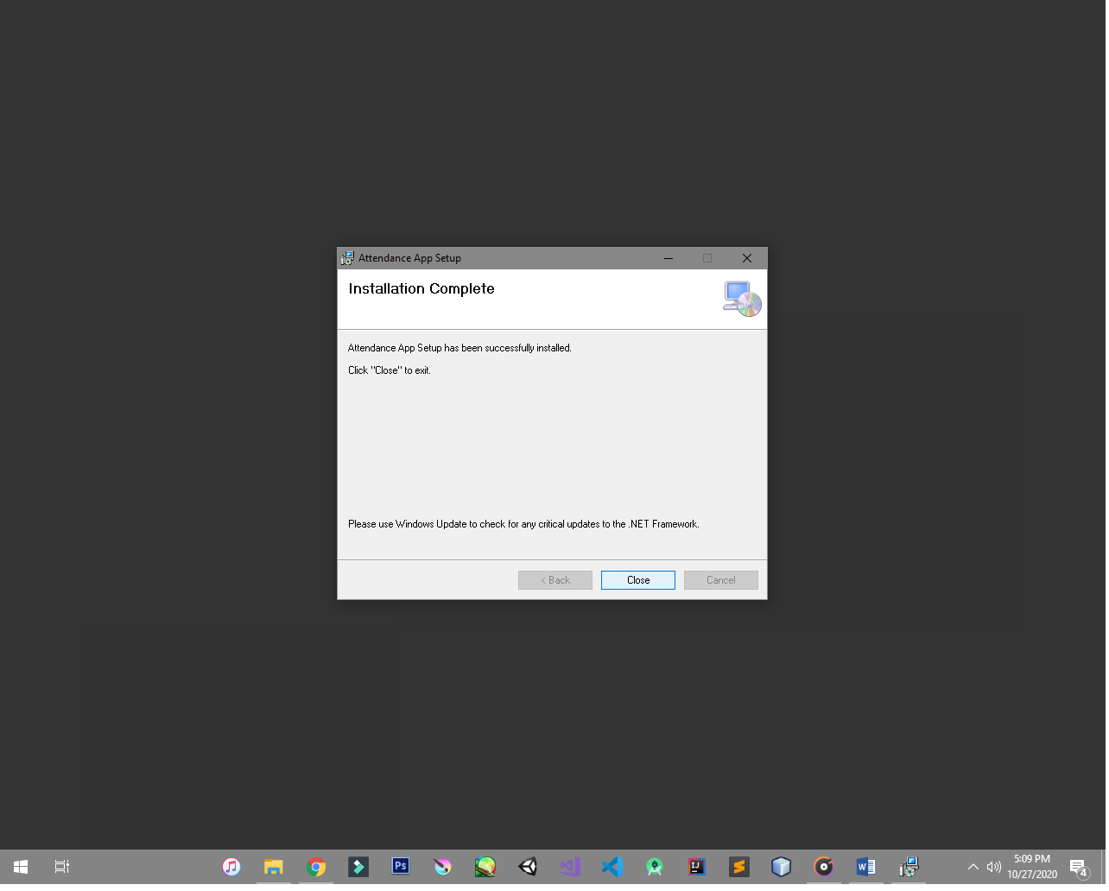

* Then go to your *windows file explorer* and paste the application directory that you previously copied and press enter

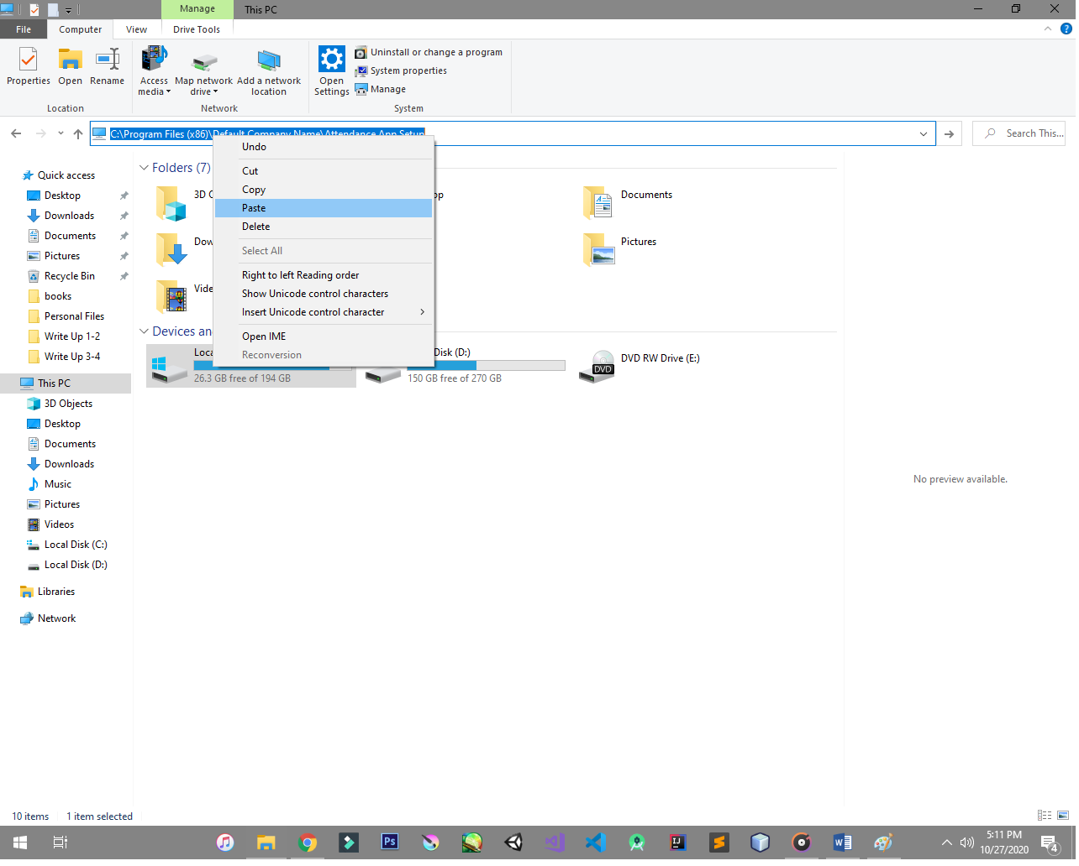

* Then find the *Attendance Application.exe* file and then right click then click **Create shortcut**

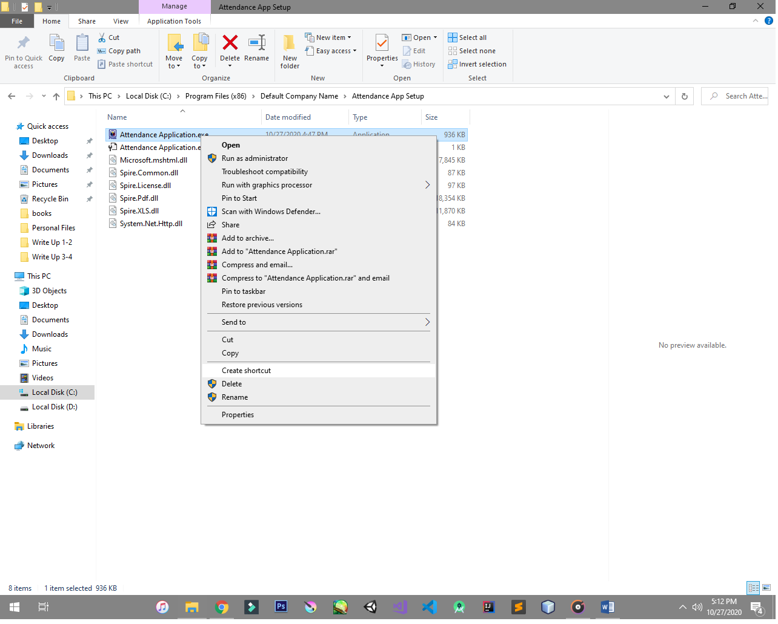

* Then if the windows appear just press ok
* If the window doesn’t appear to you just copy or drag the created application shortcut to your desktop

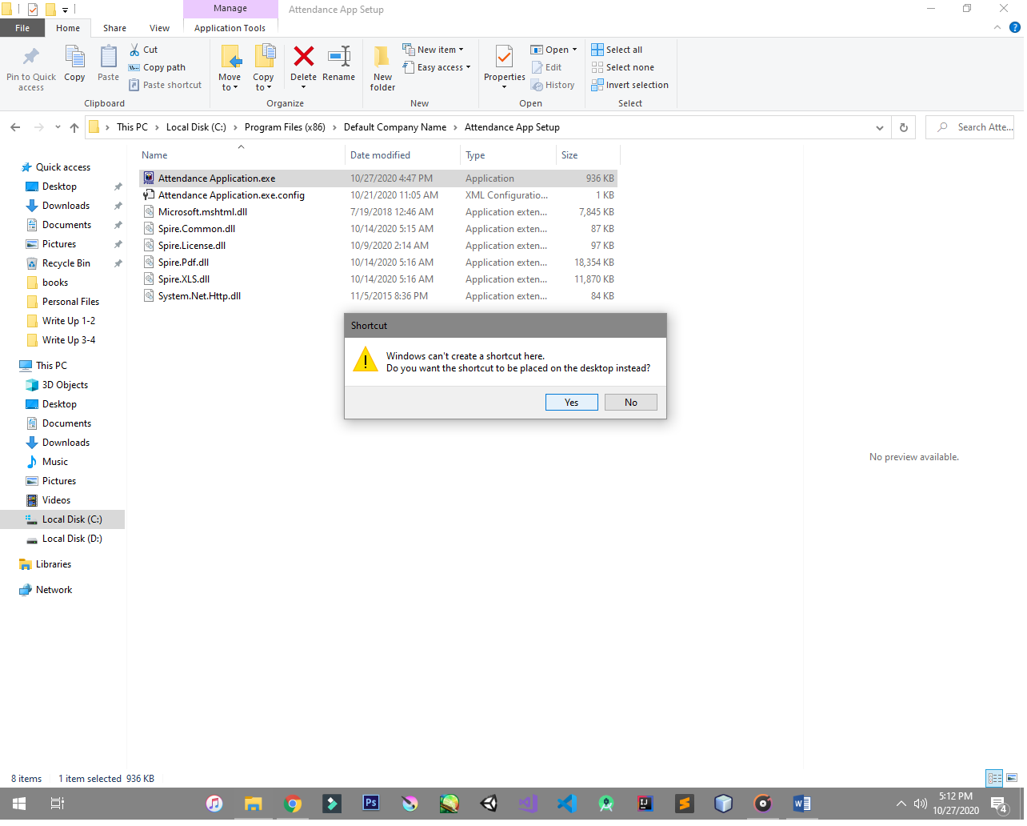

**Application Walkthrough**

* In the app main screen were you can input the name of the employee to save it in database and create attendance

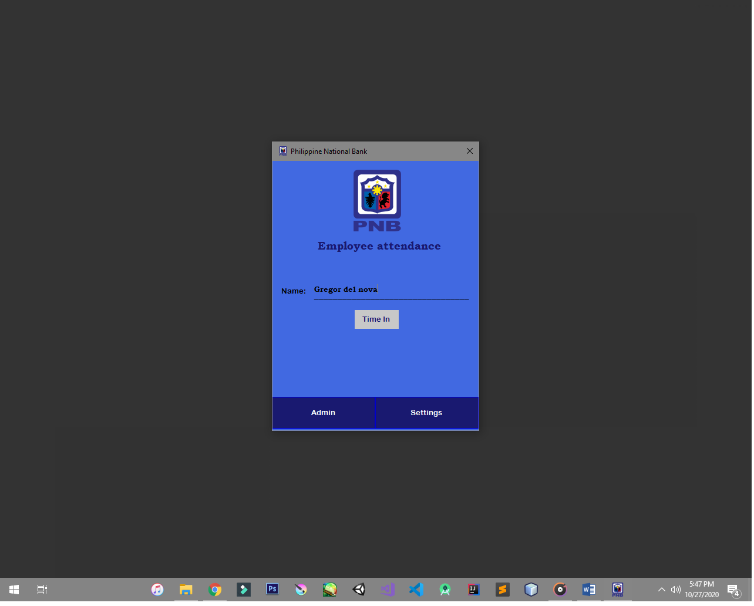

* After entering your name by clicking on time in button you will see the exact time you time in and it saves your name into database

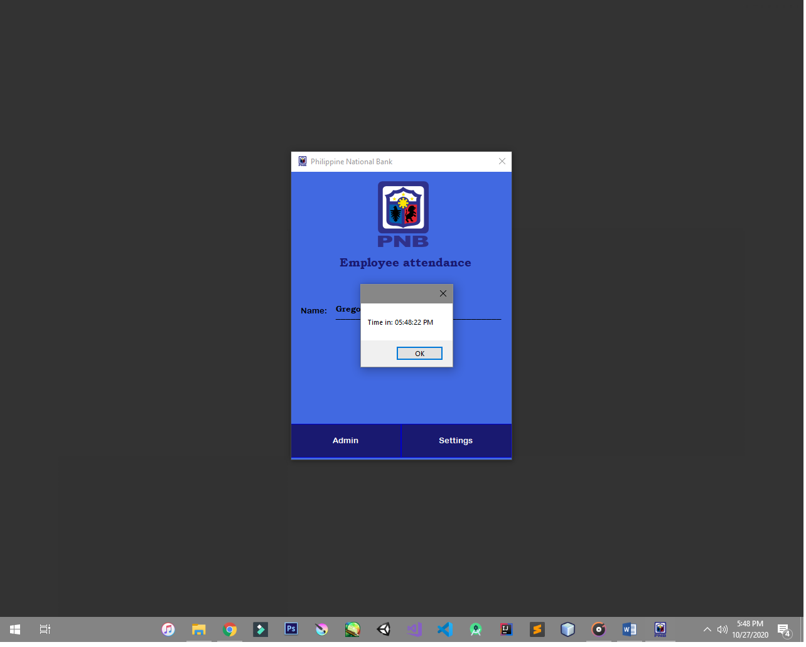

* In the settings tab you can see the field were you can change your admin passkey by default it is 012345
* It is recommended to changed it for better security in admin panel

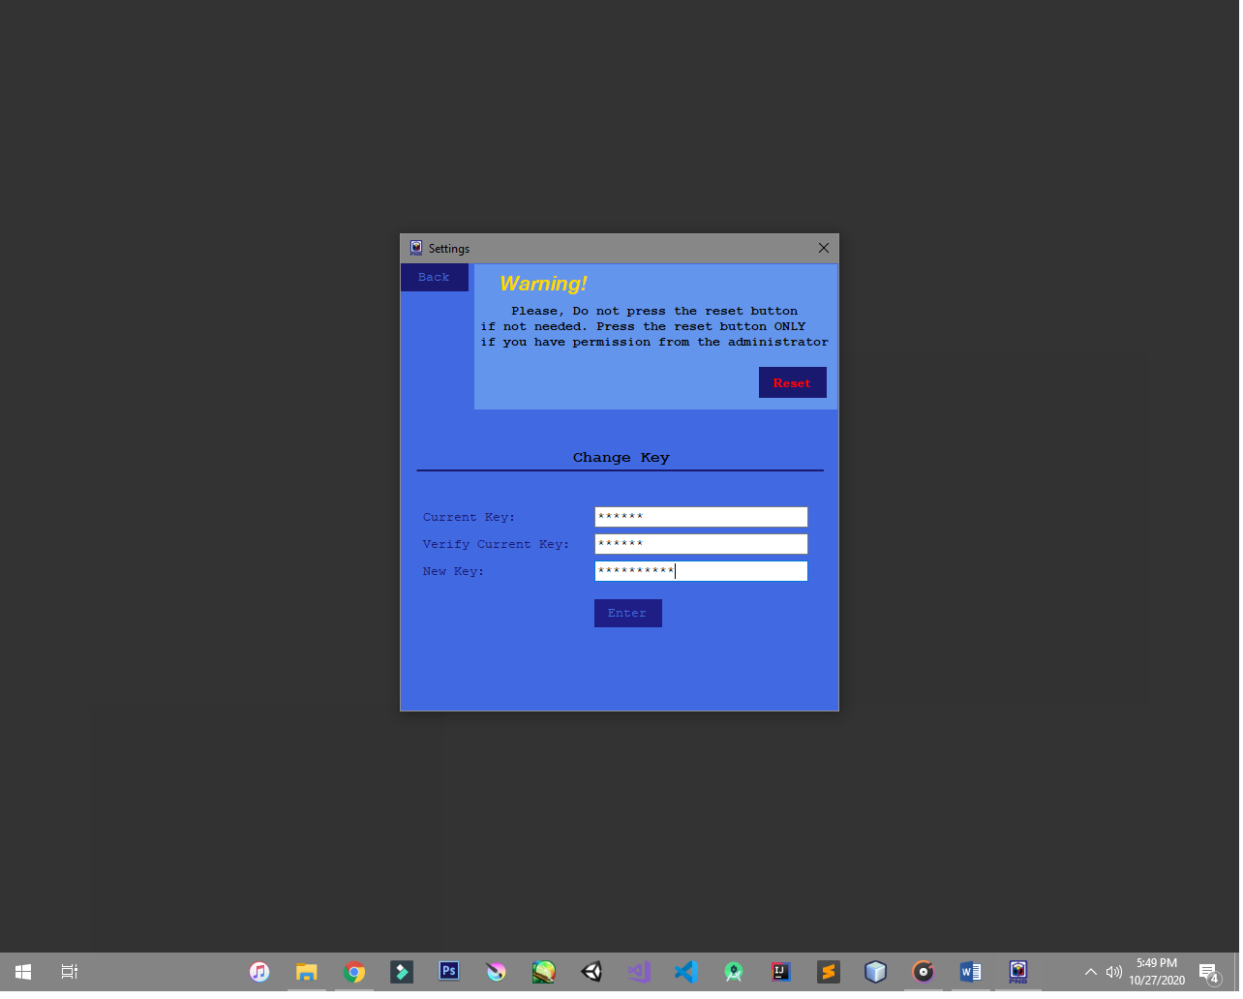

* If you forgot your passkey you can reset the application passkey by clicking the reset button in the upper right part of the settings tab
* The reset key is PNB123456 this key cannot be changed so it must be kept by the admin respectively

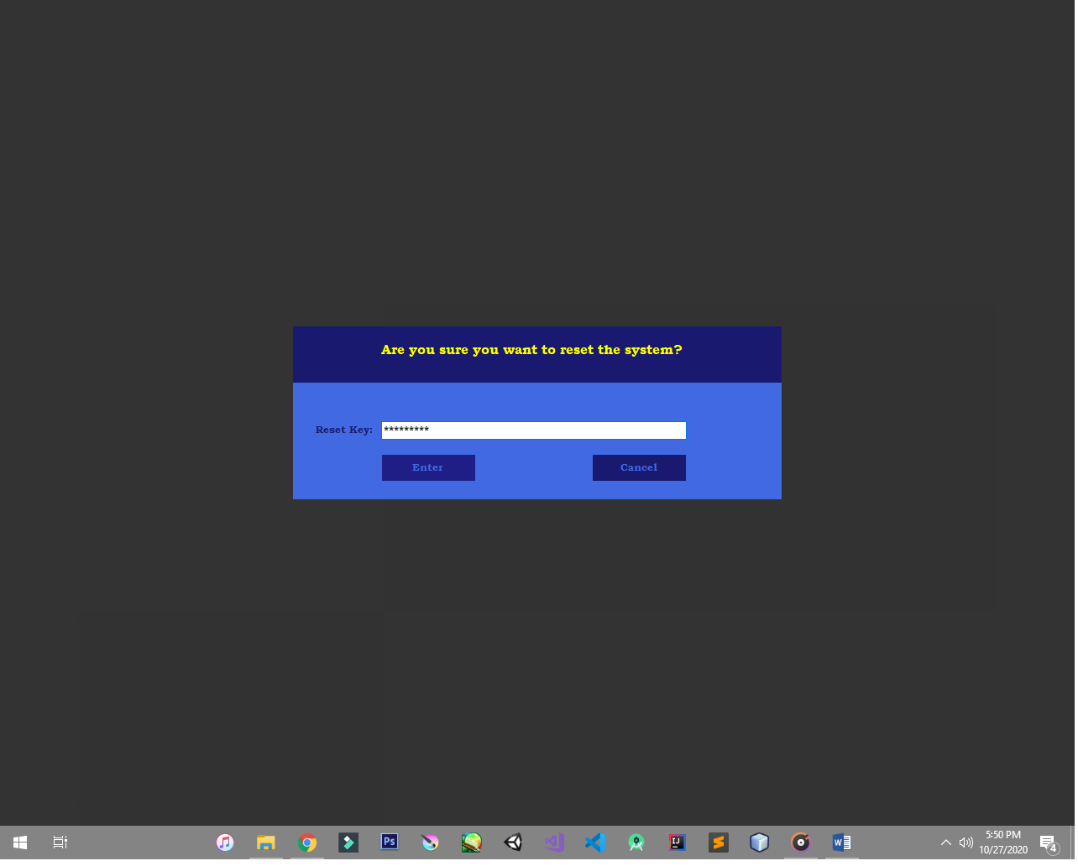

* In the admin tab, enter your passkey to access in the **admin panel** by default the passkey is 012345

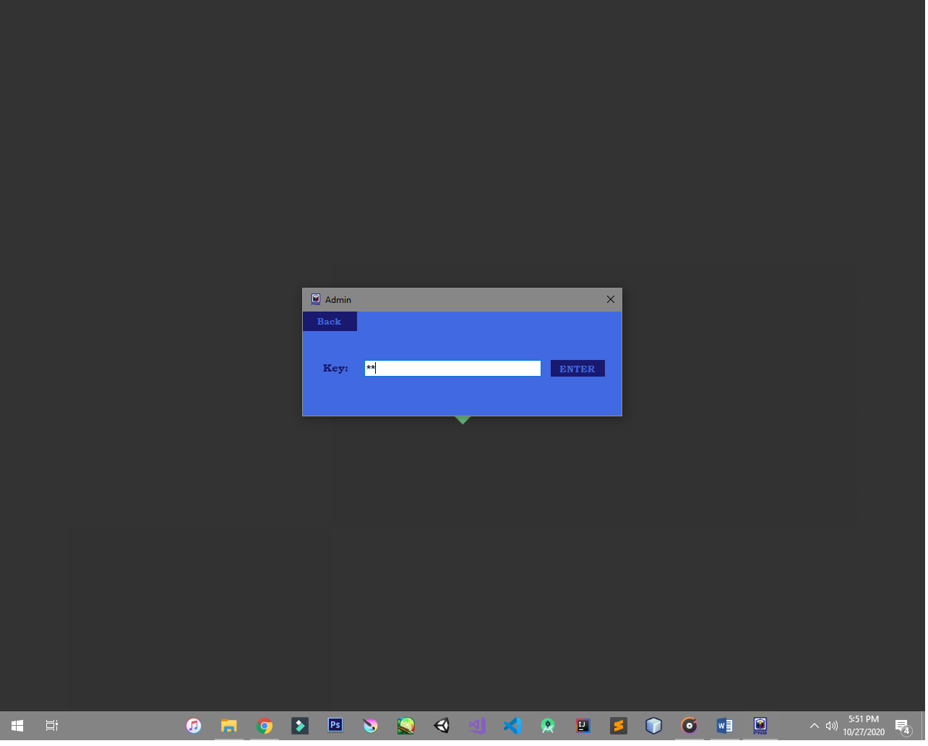

* In the admin tab you can access all employee attendance (***Name, Date, time***)
* In the admin tab, there’s 3 button
* **Back button** to go back into main screen
* **Save as button** to import and save the data into your designated file location and file name
* **Import button** to import the data into your desktop with a default settings ***(* File name/File location *)***

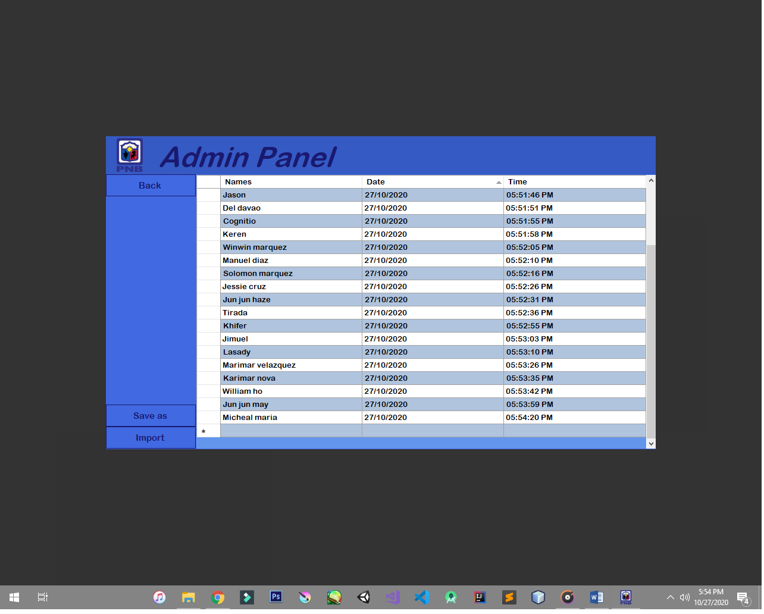

* For an instance if you have any trouble in importing the data just press

**ALT** + **TAB** to be able to see the prompt tab

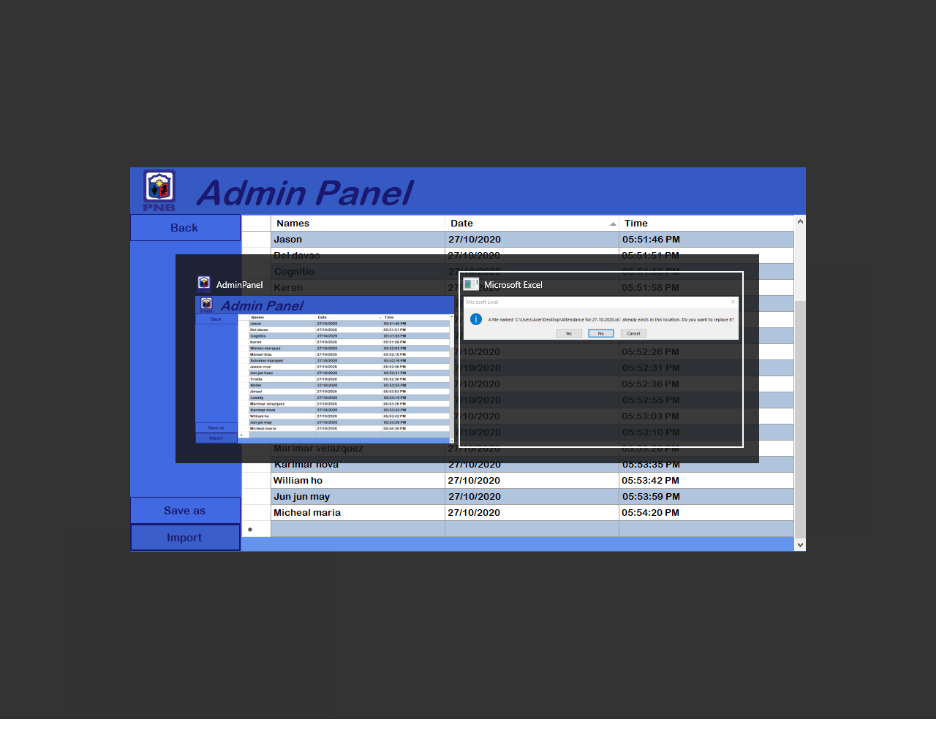

* In the save as button you can save the data **(Excel format by the default)**

In your desire file location and name

